实验5 Selenium2 页面控件的测试

|  |  |  |  |  |  |  |  |
| --- | --- | --- | --- | --- | --- | --- | --- |
| 组 别 |  | 实验人员 | KAFLE SAMRAT | | | | |
| 实验项目名称 | Selenium2 页面控件的测试 | | | | | | |
| 实 验 类 别 | 验证型□ 设计型□ 综合型□ | | | | | | |
| 实 验 工 具 | Eclipse firefox浏览器 | | | 实验地点 | J13-132 | 实验日期 | 2020.12.14 |
| 学生实验小结 | 本次实验通过selenium工具使用黑盒法中的场景法和边界值分析对程序进行测试，在eclipse中编写测试代码，输入测试数据进行测试，得到了相应结果。 | | | | | | |
| 教师评语 | 指导教师签名：  年 月 日 | | | | | | |
| 实验成绩 |  | | | | | | |

1实验内容和目标

1.1实验内容

本次实验通过使用Eclipse继续介绍Selenium WebDriver中常用的其他命令，在熟悉这些命令之后，还要求根据黑盒测试技术，针对上两次实验的登录页面设计测试用例。

1.2实验目标

（1）掌握WebDriver中一些常用的Selenium命令；

（2）学会使用黑盒测试技术设计测试用例。

2实验方案设计

2.1实验环境

SeleniumIDE firfox浏览器 eclipse

3实验步骤和结果

3.1: Write a local page for testing Selenium commands

In order to more easily learn the commands in Selenium, we need to write a web page that integrates a variety of controls, including the most basic input boxes, buttons, checkboxes, check boxes, drop-down lists, etc. The detailed code is detailed in Appendix I.

After you've written the HTML file, place it in Selenium (create your own folder) under Tomcat's webapps directory:

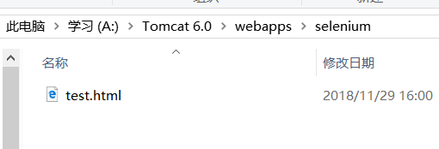

After from Tomcat folder start Tomcat in the bin, accessed through

<http://localhost:8080/selenium/test>. html page:

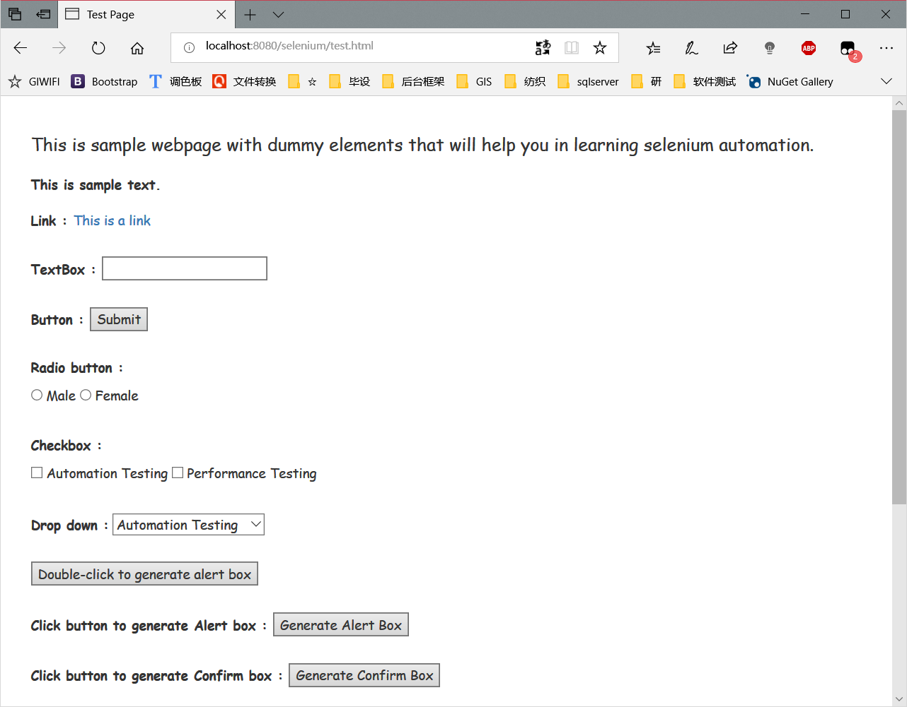

3.2: Learn some of the most commonly used Selenium commands in WebDriver

3.3: Design and test test cases according to black box testing techniques

For <https://passport.csdn.net/passport_fe/login>

.html account login function integrated use of black box testing technology, choose the right method to design test cases, requires the use of scenario and at least one other method to design test cases. Write the designed test cases and the results of the tests in the lab report.

Note that the login button is not clickable when the account and password are not filled in.

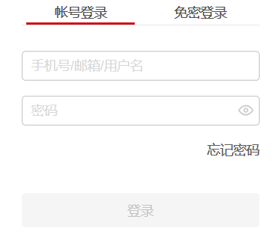

After designing the test cases, please test the test cases yourself according to what you have learned about Selenium automated testing methods.

Scenario:

1. Analyze the requirements and identify the basic flow and alternative flow of the use case

|  |  |
| --- | --- |
| The basic flow | The user opens the CSDN login interface, enters the account number and password, and returns to the main page after successful login |
| Alternate stream 1 | account does not exist |
| Alternate stream 2 | account error |
| Alternate stream 3 | password error |
| Alternate stream 4 | account password has an unfilled click on login |
| Alternate stream 5 | has no reaction |

1. Generate different scenarios based on the basic flow and each alternative flow

|  |  |  |
| --- | --- | --- |
| Scenario 1: Login successfully | base stream | alternative stream 1 |
| Scenario 2: The account does not exist | base stream | alternative stream 2 |
| Scenario 3: Account error | base stream | alternative stream 3 |
| Scenario 4: Password error | base stream | alternative stream 4 |
| Scenario 5: Click Login when there is an unfilled password | base stream | alternative stream 5 |

1. Design corresponding test cases for each generated scenario

|  |  |  |  |  |
| --- | --- | --- | --- | --- |
| Test case ID | Scenarios/Conditions | account | password | The expected results |
| 1 | Scenario 1: Login successfully | V | V | Jump to the main page |
| 2 | Scenario 2: The account does not exist | I | N/A | The user name or password is incorrect |
| 3 | Scenario 3: Account error | I | V | The user name or password is incorrect |
| 4 | Scenario 4: Password error | V | I | The user name or password is incorrect |
| 5 | Scenario 5: Click Login when there is an unfilled password | N/A | N/A | 无响应 |

Scenario 1 interface (login successful)

Fill in the correct account password in the test code

Scenario 2 interface (account does not exist)

Fill in the test code that the account does not exist

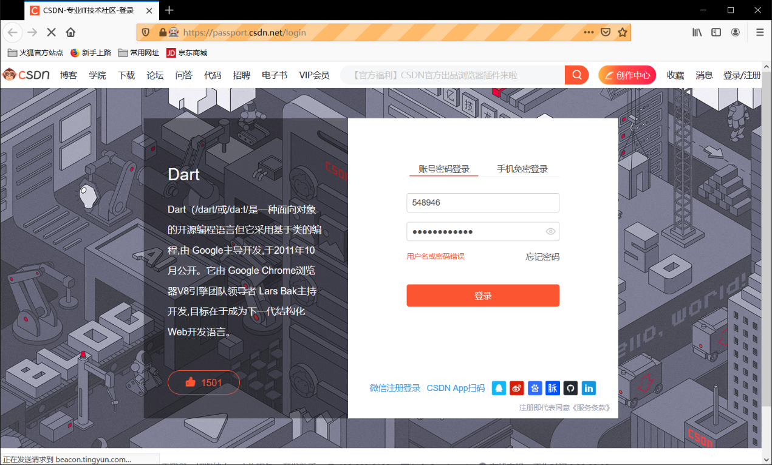

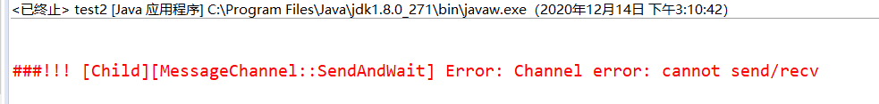

Scenario 3 interface (account error)

Intentionallyincorrect account number in the test code

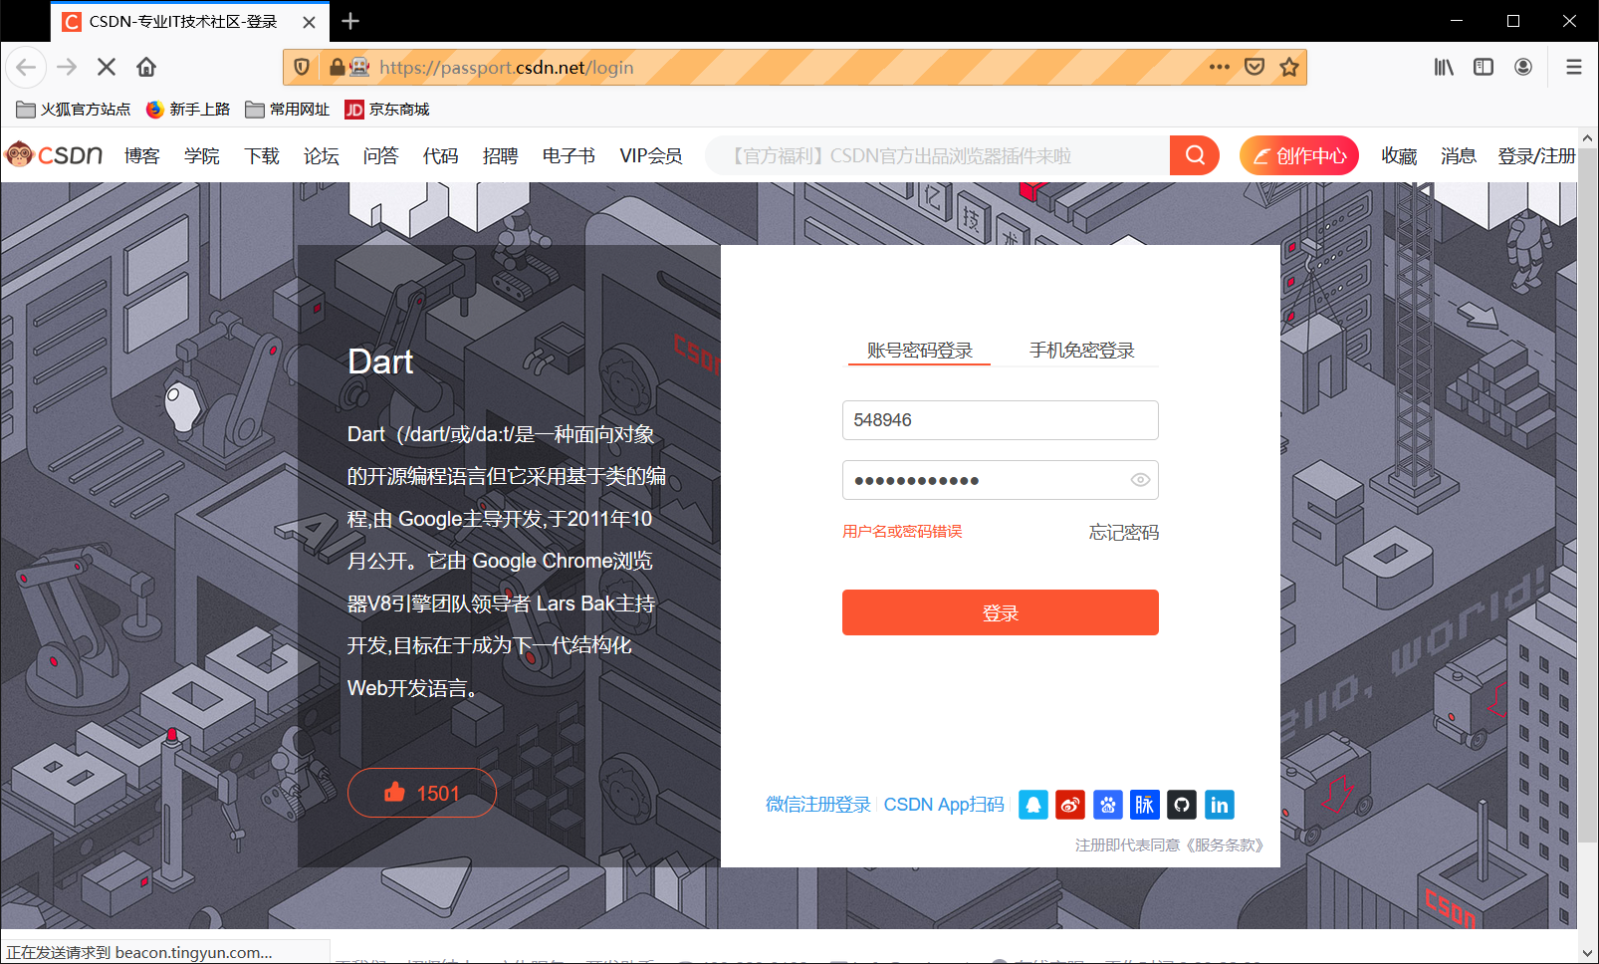



Scenario 4 interface (password error)

You deliberately misfilled a password in your test code

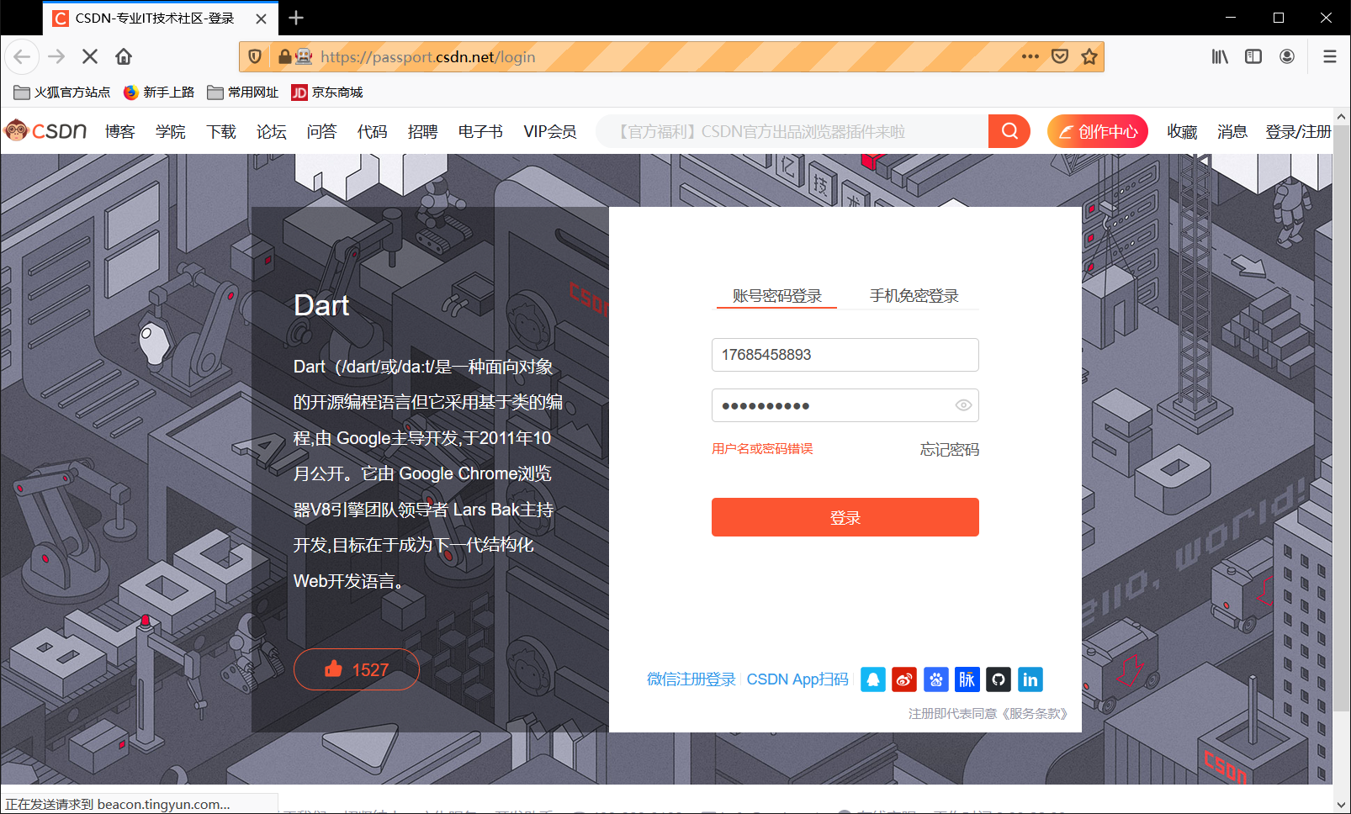



Scene 5 interface (click login if one of the account and password is not written)

Test code directly click the login button

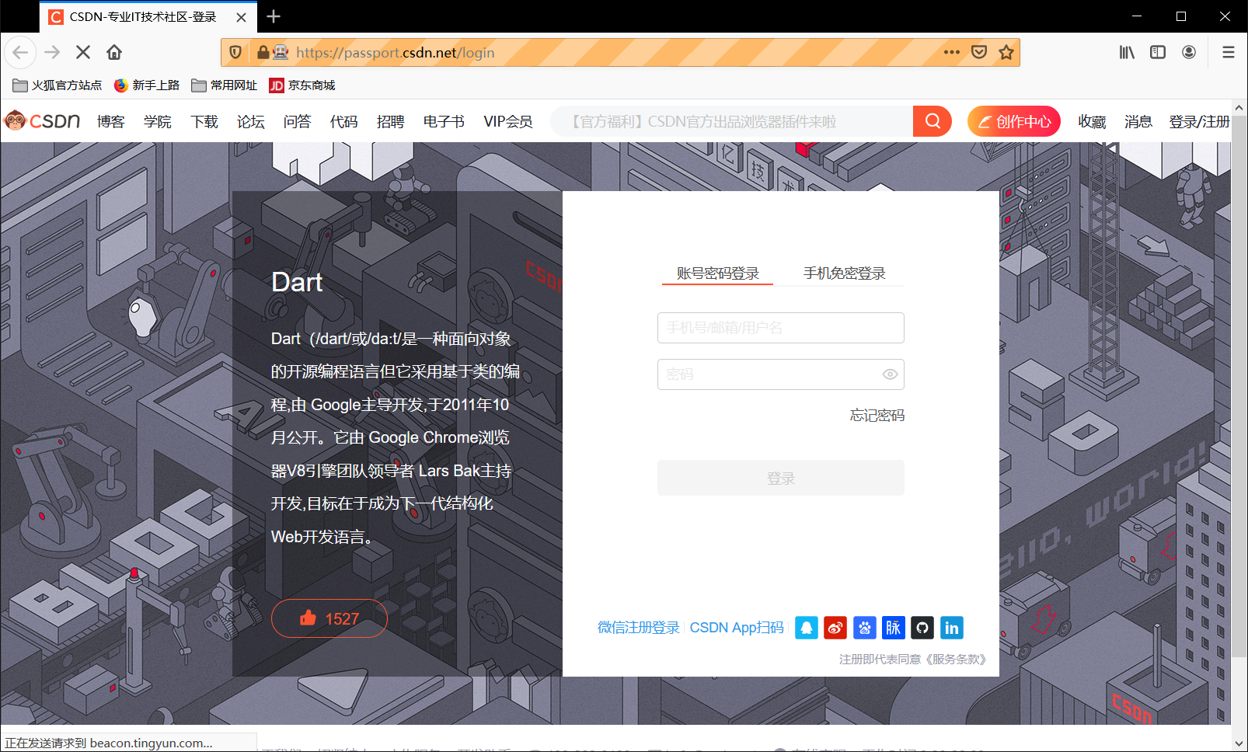

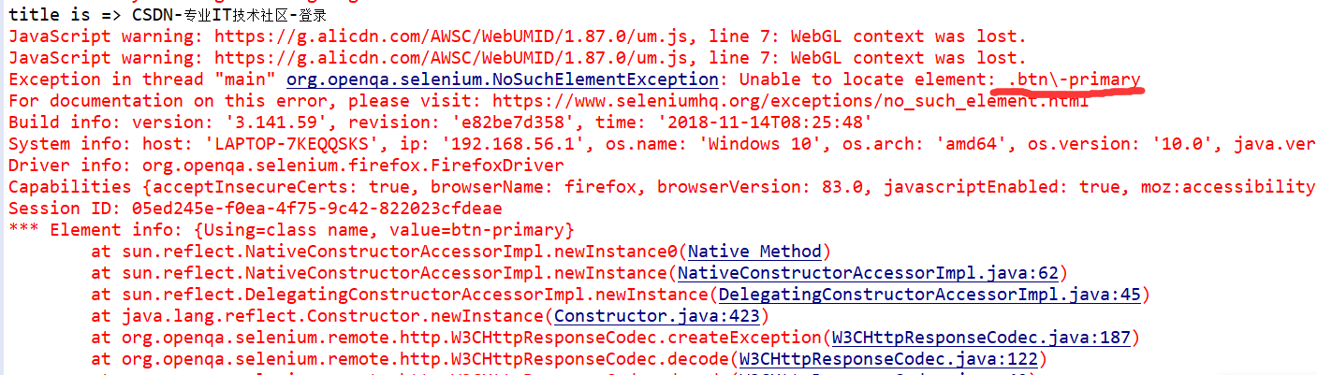

4实验结果分析

通过对登录输入的黑盒法测试，发现测试输入样例与预期结果一致。